**Melting Iceland: Mýrdalsjökull and Eyjafjallajökull**

Jessica Martinez, Rowan Moody, & Jess Strzempko  
Intro to Remote Sensing | December 13th, 2018

**Introduction**

The widespread occurrence of glacial melting in the past century has created concern for these stunning landscapes and their surrounding environments. Specifically in Iceland, a number of glaciers found in the southern region of the island have experienced severe retreat, with ice fronts receding up to hundreds of meters from previous locations in the past several decades (Evans, et al. 2017). While glaciers provide economic and aesthetic benefits through the tourist industry, these tremendous masses of ice also assist in the investigation and study of climatological history. By analyzing water isotopes and trapped gases in ice cores, researchers are able to determine historical atmospheric conditions (Casado, et al. 2018). The loss of these glaciers due to retreat means the direct loss of critical scientific information and history.

In a similar manner to the way glaciers provide a vital long-term climate record, their recent unprecedented retreat and potential disappearances allow researchers to study short-term effects of rapid climate change. Since the spread of industrialization in the early 20th century, humans have been emitting carbon dioxide and other greenhouse gases into the planet’s atmosphere, contributing to a steady rise in global temperatures. While glaciers are dynamic and always moving under their own weight, an imbalance between the rates of accumulation and ablation experienced by a glacier can lead to glacial retreat. Additionally, anthropogenic global warming melts surface ice and creates exterior meltwater ponds while also lubricating the interface between the glacier and the land (Chelsi, et al. 2015). These many direct and indirect impacts of global warming exacerbate current shrinking trends.

Due to their immense scale and dynamic nature, the techniques of remote sensing and its predecessors have always been a preferred method to study changes in glacial extent. In Hannell and Ashwell (1959), physical maps and aerial photography are used to study the recession of an Icelandic glacier from the 1930’s to the 1960’s. Currently, remote sensing is being applied to the study of water-filled ice depressions on the surface of glaciers to predict sudden releases of glacial water due to melting (Chelsi, et al. 2015). Since water in its many phases has a number of different spectral signatures, remote sensing techniques are best positioned to distinguish spatial patterns for these types of environments.

**Research Objectives**

The purpose of this study is to characterize changes in the extents of Icelandic glaciers by conducting land cover type classifications for a scene in the southern region of Iceland around the Mýrdalsjökull and Eyjafjallajökull glaciers across 3 time periods (1988, 1996, and 2014) spanning the last several decades. The Mýrdalsjökull and Eyjafjallajökull glaciers are found next to each other at the southern tip of the island. Mýrdalsjökull is the larger glacier to the right within the highlighted area, while Eyjafjallajökul is the smaller glacier to the left. The central approach is to perform and subsequently harden a supervised soft classification on Landsat imagery for each time period to distinguish and map the temporal variability of land cover types in the region. By mapping glacial extent as one of these land cover classes, the goal is to quantify the changes in size of the Mýrdalsjökull and Eyjafjallajökull glaciers across approximately 30 years. An additional objective is to compare the classification maps from 1988, 1996, and 2014 to provide a summary of general land cover trends seen in the area with potential environmental or anthropogenic explanations.

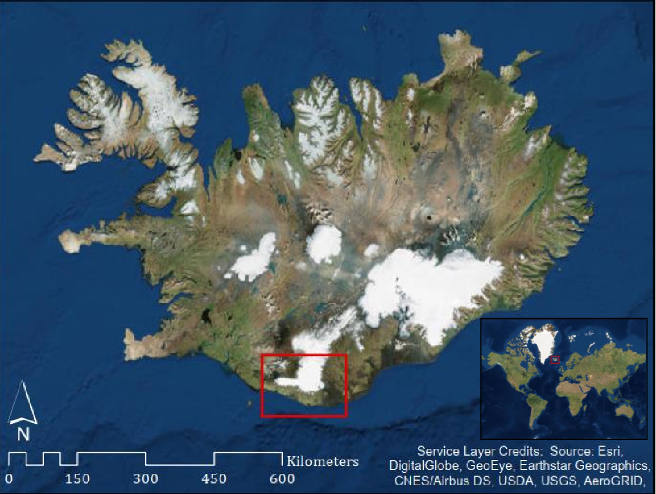

Figure 1: Map of Iceland showing the extent of the region surrounding Mýrdalsjökull and Eyjafjallajökull glaciers chosen as the study site.

**Data Description**

The data used in this study were downloaded through USGS Earth Explorer. Remotely sensed images from 1988, 1996, and 2014 were chosen based on the seasonality criteria (summer months showing higher contrast between land cover types), and the lack of disruptive cloud cover. The 1988 and 1996 images were captured by the Landsat 5 satellite along row 219 and path 15 at 30x30 meter spatial resolution, while the 2014 image was captured by the Landsat 8 image along the same row and path and also at 30x30 meter spatial resolution (Figure 2). While Landsat 8 imagery offers higher spatial resolution in some of its bands, the bands chosen for analysis were all captured at 30x30 meters. Only the visible, Near-Infrared, and Shortwave Infrared bands for each image were imported through the Landsat archive import module in Terrset, with the addition of the Cirrus band for the 2014 image. All bands utilized for classification were atmospherically corrected through the Landsat archive import under Cos(t) atmospheric correction. Figures 3, 4, and 5 show the full extent of the captured images in true color composites (blue, green, and red bands), prior to their windowing to the study area extent. All three images were projected in WGS_1984_UTM_Zone_27N for analysis and visualization.

| **Capture Date** | **Satellite** | **Spatial Resolution** | **Bands used in Classification** | **Source** |
| --- | --- | --- | --- | --- |
| September 12, 1988 | Landsat 5 | 30 m x 30 m | Blue (1), Green (2), Red (3), NIR (4), SWIR1 (5), SWIR2 (7) | Earth Explorer, USGS |
| August 17,  1996 | Landsat 5 | 30 m x 30 m | Blue (1), Green (2), Red (3), NIR (4), SWIR1 (5), SWIR2 (7) | Earth Explorer, USGS |
| August 19,  2014 | Landsat 8 | 30 m x 30 m | Blue (2), Green (3), Red (4), NIR (5), SWIR1 (6), SWIR2 (7), Cirrus (9) | Earth Explorer, USGS |

Figure 2: Data table showing the acquisition dates, satellite and download sources, as well as spatial resolution of bands utilized in classification.

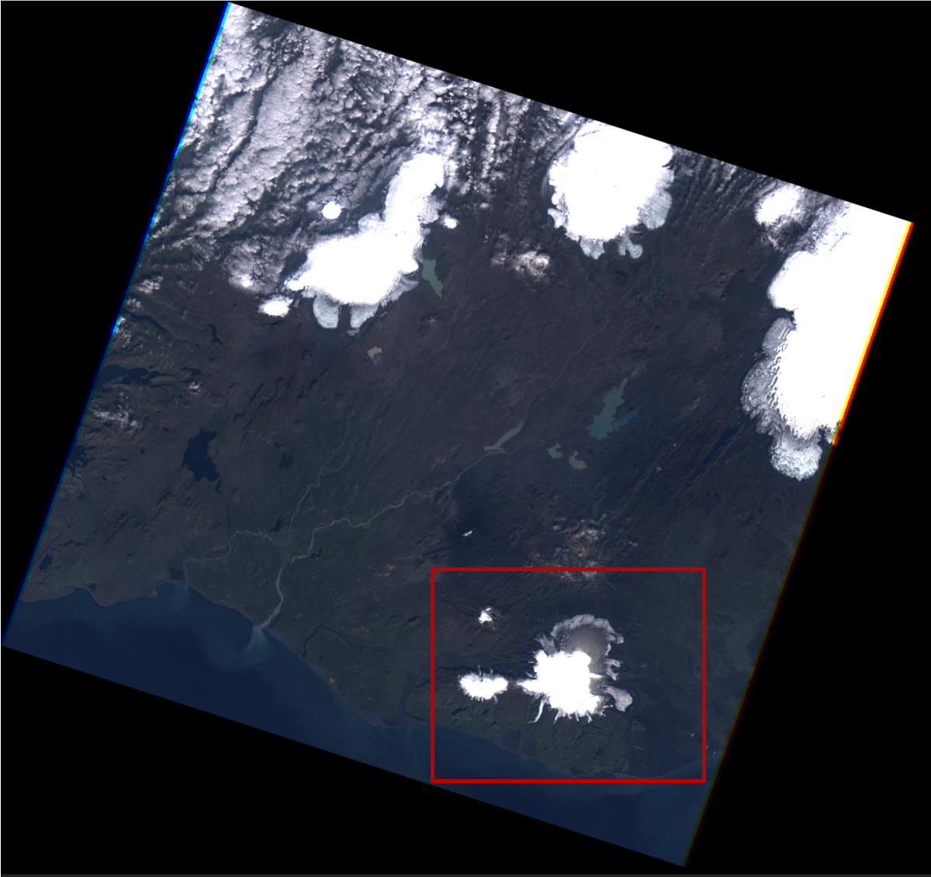

Figure 3: True color composite of 1988 image.

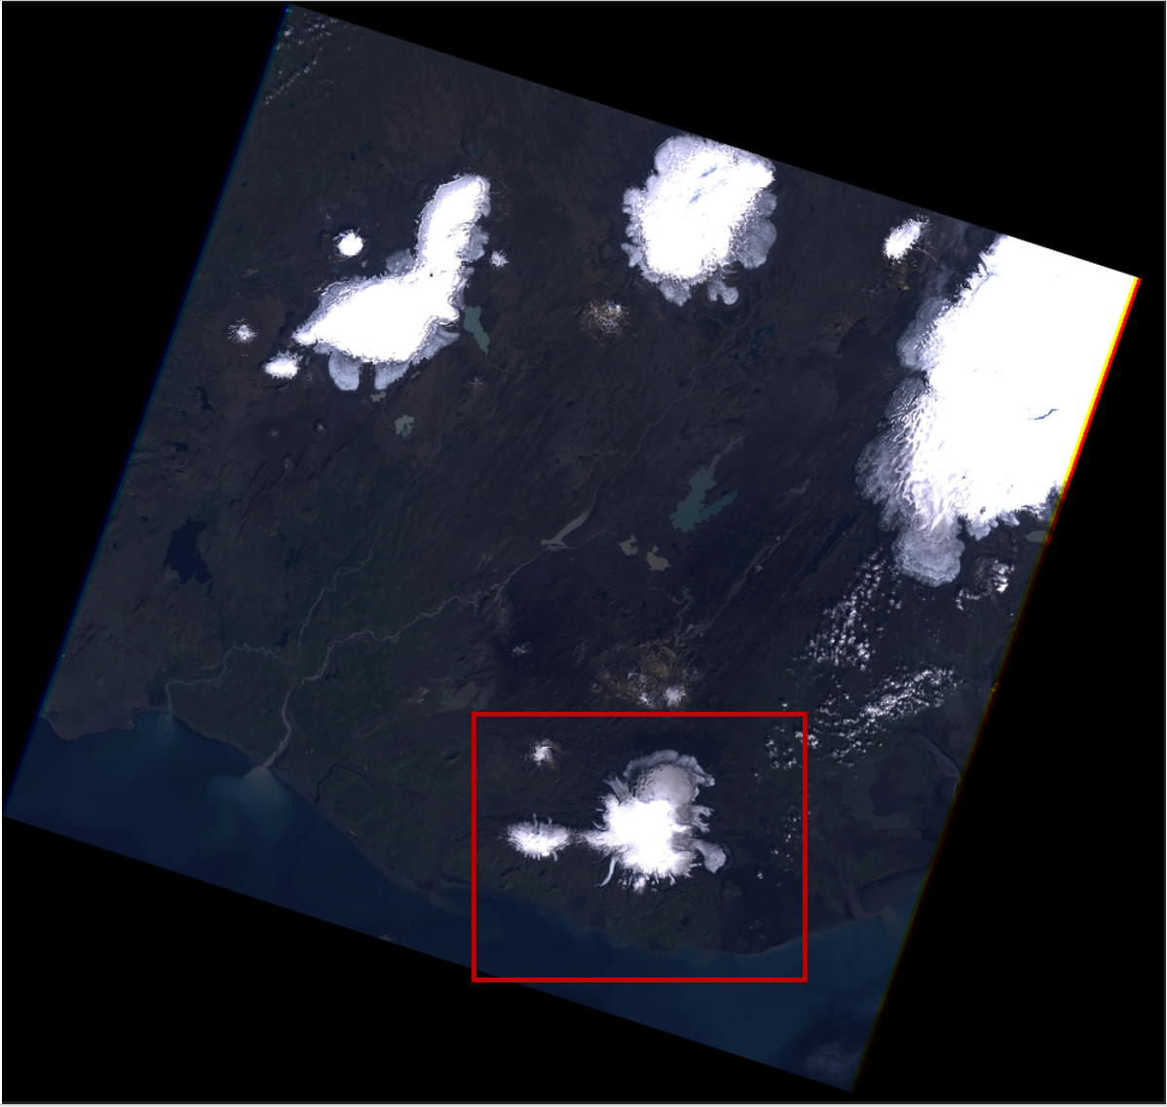

Figure 4: True color composite of 1996 image.

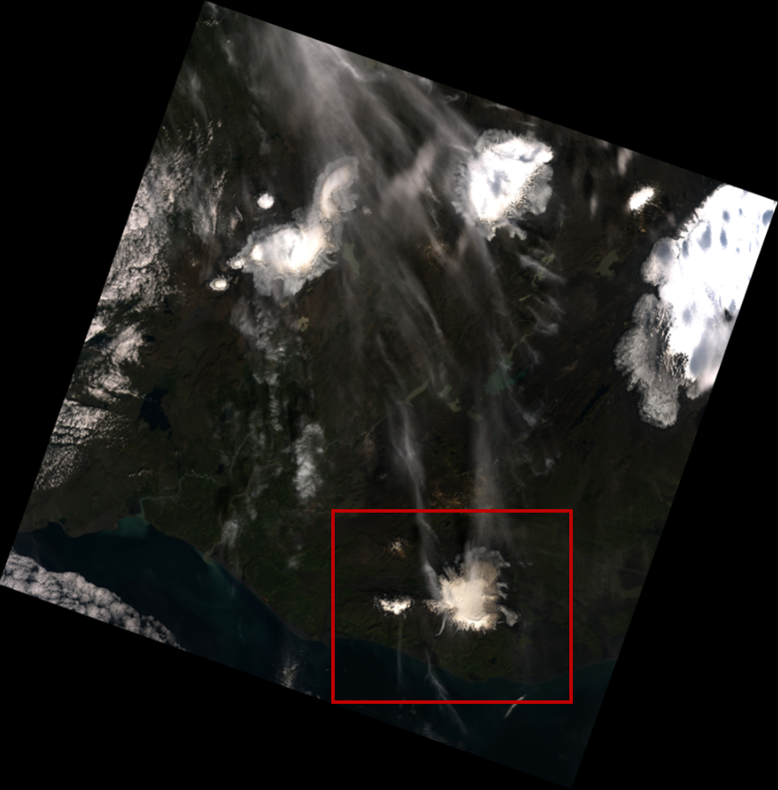

Figure 5: True color composite of 2014 image.

**Methods**

Given that our research objectives to perform a supervised classification surrounded the overarching goal to identify the extent to which the Mýrdalsjökull and Eyjafjallajökull glaciers have decreased over time, we choose to examine the extent of the glacier melt through the years of 1988, 1996, and 2014. The classification process was identical for each year. To avoid redundancy, the following methodology will focus on the overall steps performed cumulatively while explaining slight differences addressed for each year. The analysis and classification for 1988 was performed by Rowan Moody, 1996 was performed by Jess Strzempko, while 2014 was performed by Jessica Martinez.

After the 1996, 1988 and 2014 images were imported into TerrSet and atmospherically corrected using Cos(t), the 1996 band 4 image was considered as our base image for windowing. The window for 1996 was specified by row and column positions. The upper-left column was specified as 3249, the upper-left row as 5006 to the lower right column 5849 to the lower right row of 6809. The extents for the 1988 and 2014 images were based off of this window. True color and false color composites were created using the windowed bands. False color composites were created to perceive a better differentiation of the vegetation and glacial cover within the study extent, while the true color composites were created to fathom a general understanding of the different land covers present. For both the 1988 and 1996 images (captured from the Landsat 5 satellite), true color composites were created using the COMPOSITE module in TerrSet, in which bands 1 (wavelength from 0.45 micrometers to 0.52 micrometers), 2 (0.52-0.60 micrometers), and 3 (0.63 micrometers to 0.69 micrometers), were periodically assigned to blue, green and red. False color composites were created by assigning bands 2 (Green), 3 (Red), and 4 (Near Infrared) to blue, green and red. By using the Near Infrared band, vegetation was readily detected through the image by portraying it in the color red. Comparatively for 2014, the same process and reasoning was executed for each composite, but different bands were used as the imagery was taken from the Landsat 8 sensor. Therefore, for the true color composite, bands 2 (wavelength from 0.452 micrometers to 0.512 micrometers), 3 (0.533-0.590 micrometers), and 4 (0.636-0.673 micrometers) were assigned to blue, green and red. Again, the band numbers for the false color composite also shifted down a band number in which band 3 (Green,) 4 (Red) and 5 (Near Infrared) were assigned to blue, green and red image bands.

The false and true color composites allowed for the determination of information classes to initiate the classification process. Based on the composites for each year as well as further analysis through google earth, a total of five training sites were digitized for each year. In result, polygon layers were created for the following information classes:

1 = Water

2 = Vegetation

3 = Snow

4 = Black Sand/Bare Soil

5 = Clouds

Clouds were assigned a separate training site to ensure that they would not be misclassified as snow. Out of the three dates in which we analyzed, the 1996 and 2014 images proved to have the most cloud presence. Although the clouds did not impendingly cover the Mýrdalsjökull and Eyjafjallajökull glaciers, pure training sites were created in order to receive the most truthful classifications as possible. Upon completion of digitizing individual layers for each information class, the module MAKESIG was used to create class signatures for which they were then evaluated through the module SIGCOMP (Signature Comparison Chart). Overall, all of our class signatures were well separated from one another across all three dates as shown in Figures 6, 7, and 8 below, which allowed us to proceed to our classification methodology.

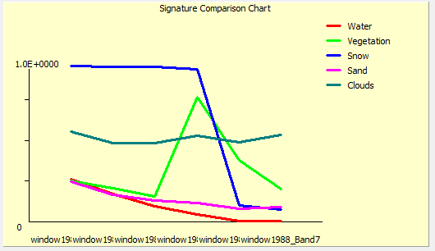  
Figure 6: 1988 signature comparison Figure 7: 1996 signature comparison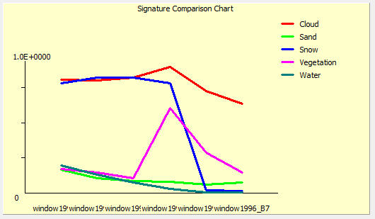

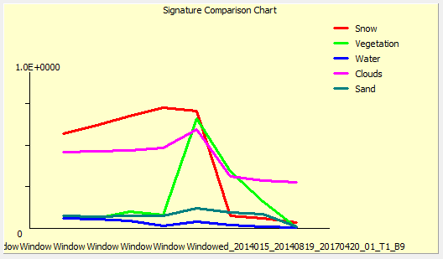

Figure 8: 2014 signature comparison

For the classification, we choose to perform linear spectral unmixing. This classification method was chosen in regards to the abundance of land cover variability within the spectral resolution of the images we selected to analyze. Given that pixels were mixed with multiple land cover types (such as vegetation, sand and snow), we reasoned that linear spectral unmixing could provide the best separation of these classes while providing weights as to how much each pixel belonged to each class. This provided us with a sufficient understanding of the landscape for each data set and how they compare to one another, before Hardening was later performed.

Using the proportions from the spectral linear unmixing results of water, vegetation, snow, bare soil and clouds, the HARDEN module was run using the minimum default threshold of 0 for each class. The overall analysis of this project was conclusive upon the hardened output for all three years. A custom palette was made in symbol workshop and applied to the outputs to provide a clear visualization of the land cover variation across 1988, 1996 and 2014. As displayed in the resulting classification in the results section, water (1) was set to a royal blue color, vegetation (2) was set as a forest green color, snow (3) was set as a light ice blue color, bare soil (4) was set to a deep purple/grey color while clouds (5) was set as pink. The color pink was chosen for clouds for arbitrary distinction from all other classes. Since our analysis primarily focused on the change in glacial extent across the three years, the distinction of clouds was important to allow for the focused analysis of the other land cover classes.

**Results**

Initial results from the 1988 classification included a large misclassified area in the northern region of the Mýrdalsjökull glacier. Training site modifications were attempted, but there was little change in results. To best provide an accurate earliest image to compare future land cover changes against, the misclassified area was digitized as a polygon with a matching ID to the Snow/Ice information class. The Terrset RASTERVECTOR tool was used to convert this vector polygon into raster format and overlay it into the 1988 classification. The result from this procedure showed a reasonable base image for comparisons (Figure 9). The training sites for this classification were based off the land cover types identified in the false color composite (Figure 10), and the windowed true color composite (Figure 11). The full extent of the two glaciers can clearly be seen (Eyjafjallajökull is the small glacier in the left of the image, while Mýrdalsjökull is the larger glacier to its right), as well as areas of dark material classified as water and sand surrounding the glacier edges. Additionally, there is minimal cloud cover identified throughout the image, allowing for clear classification.

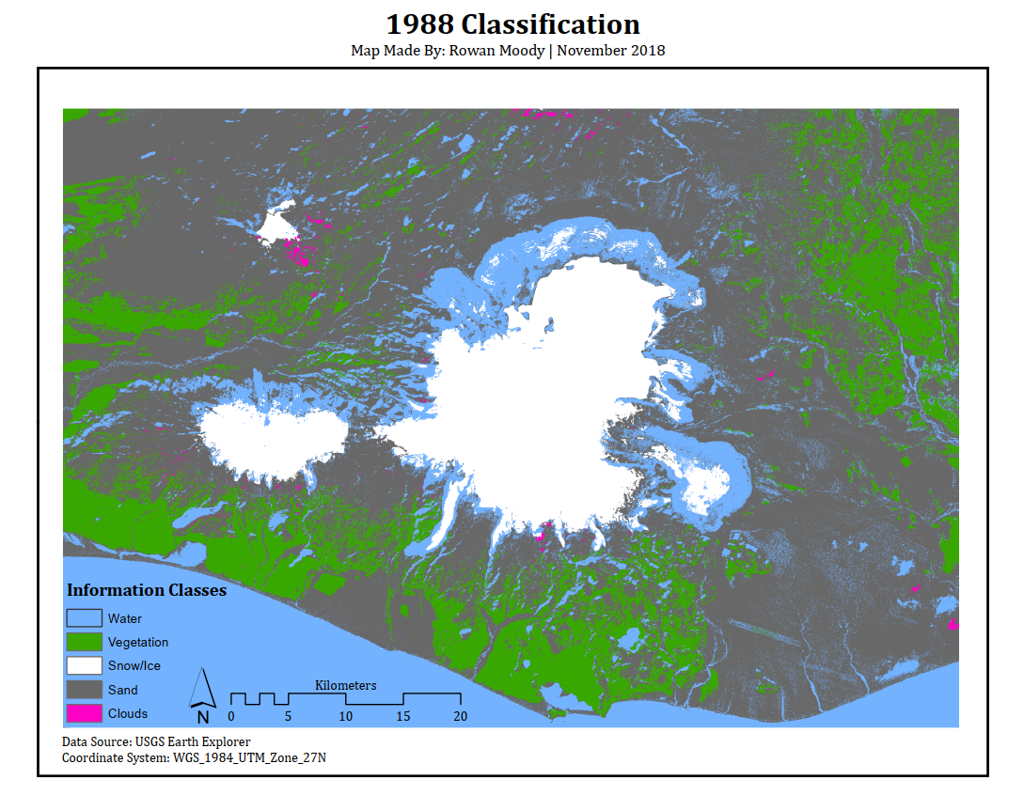

Figure 9: Results of the Linear Unmixing classification for the year of 1988

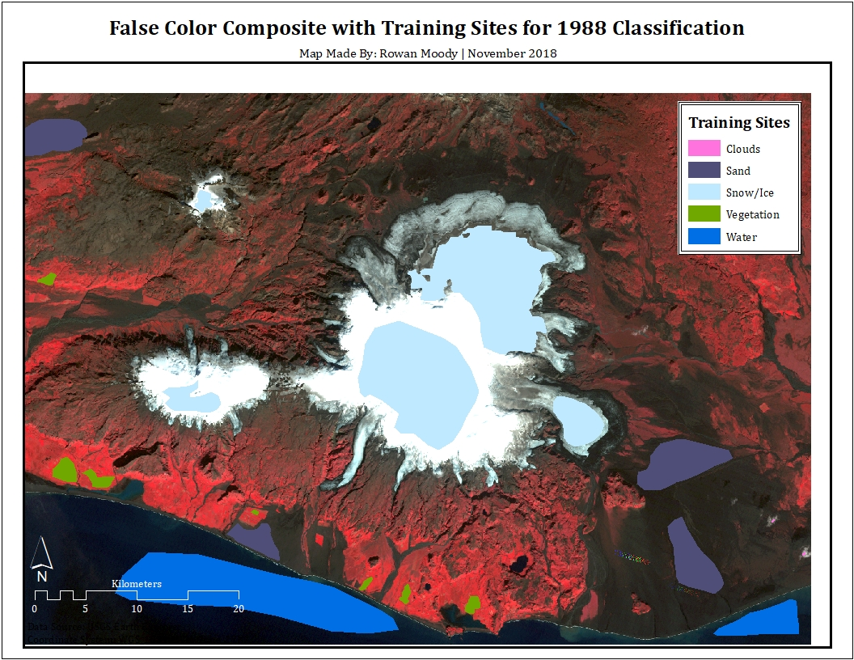

Figure 10: False color composite (green, red, NIR) including the training sites used in the 1988 classification. The large northern-most Snow/Ice polygon on the Mýrdalsjökull glacier was overlaid into the final classification image to provide a more complete glacial extent for classification comparison

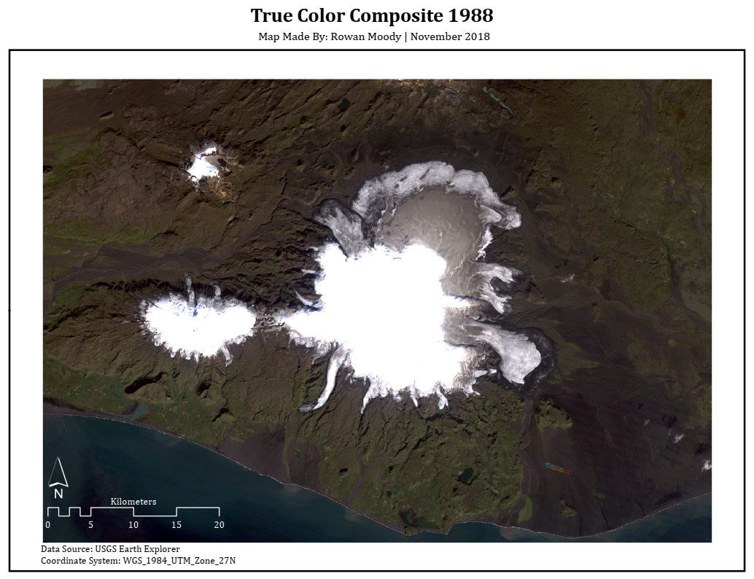

Figure 11: Windowed true color composite for the year of 1988

The results from the 1996 classification (Figure 12) show few visible differences from the 1988 classification, with the exception of a higher abundance of cloud cover. A different distribution of training sites was used in this classification than was used on the 1988 classification, as can be seen in Figure 13. These sites were again based off land cover identified in the false color composite and windowed true color composite (Figure 14).

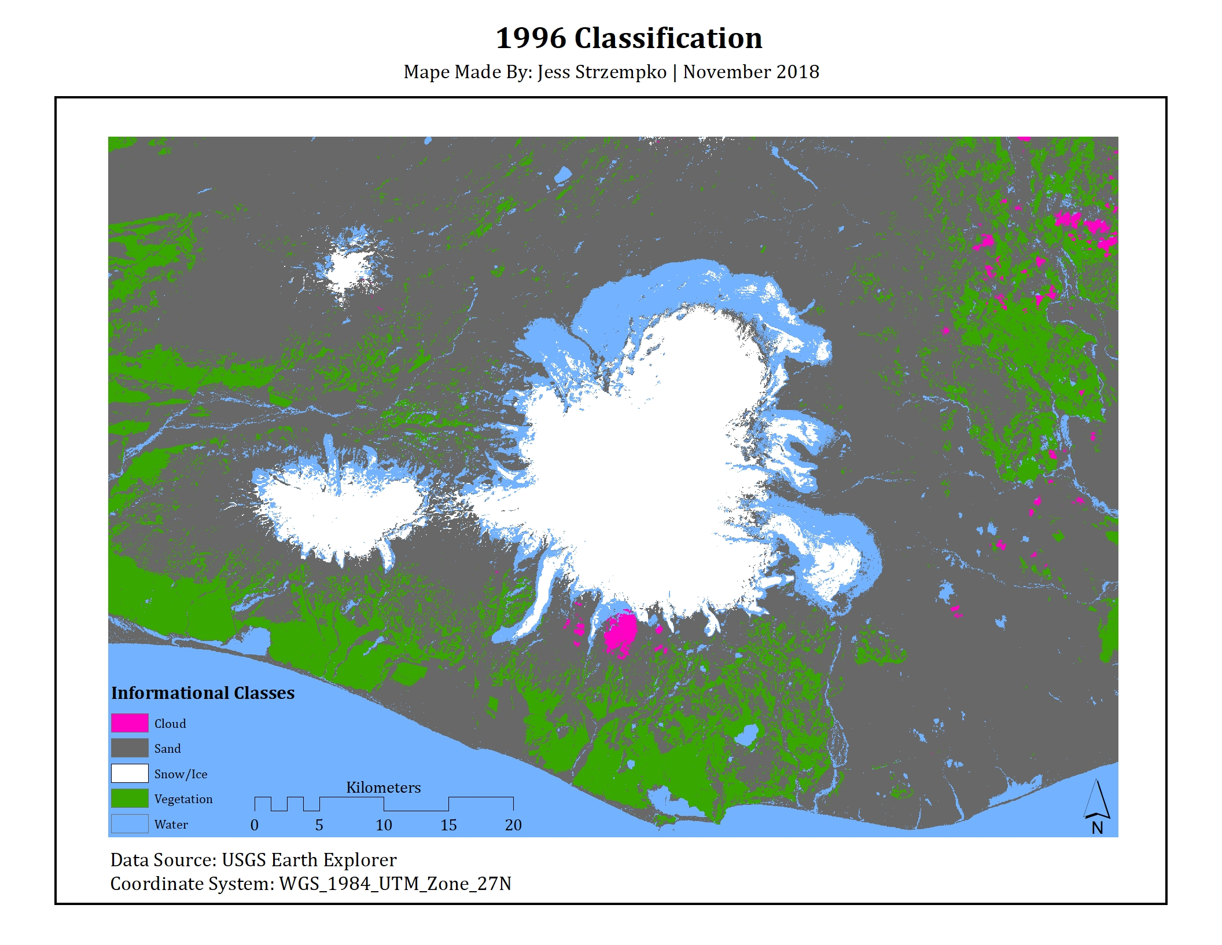

Figure 12: Results of the Linear Unmixing classification for the year of 1996

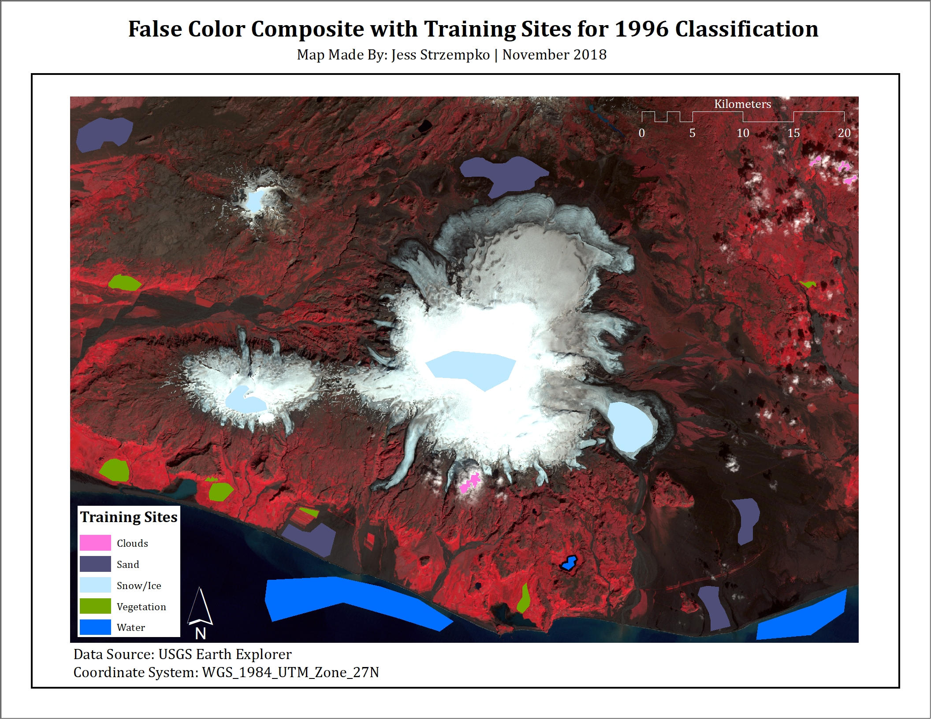

Figure 13: False color composite (green, red, NIR) including the training sites used in the 1996 classification

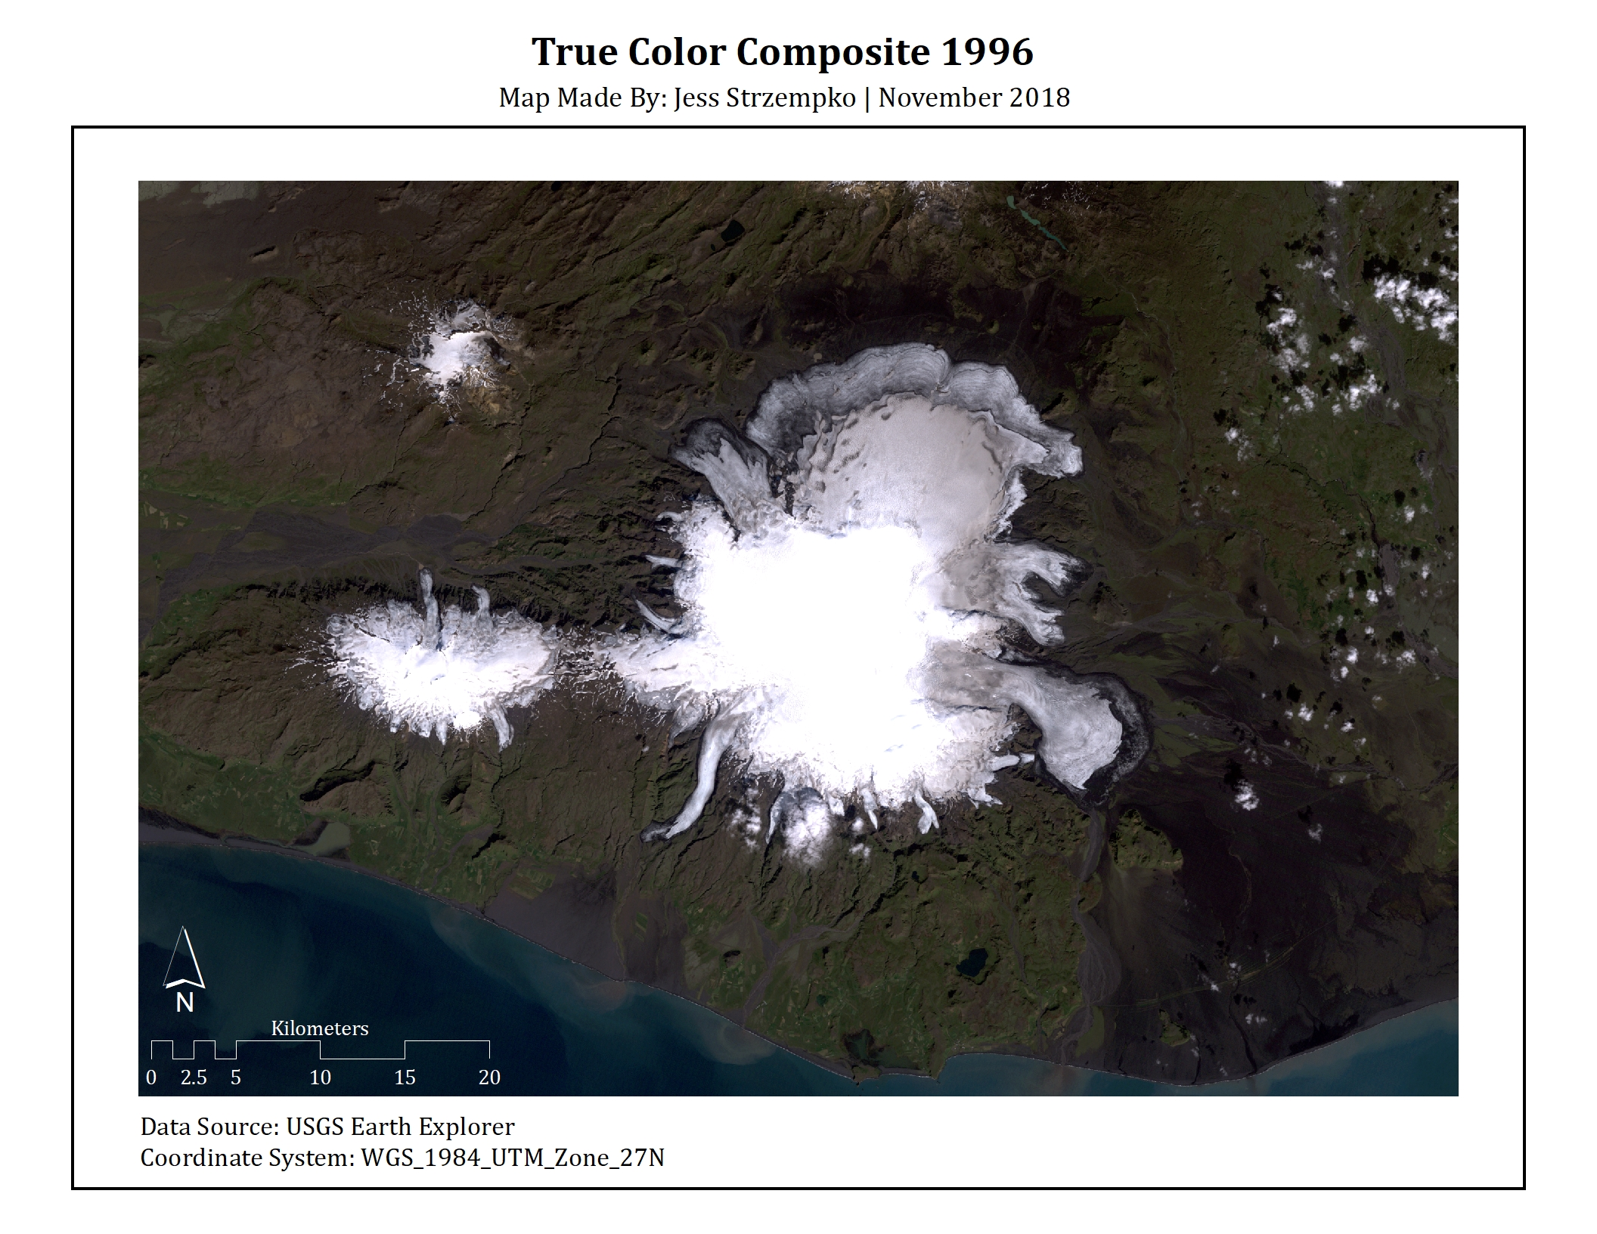

Figure 14: Windowed true color composite for the year of 1996

The results from the 2014 classification (Figure 15) show the most difference from our 1988 classification, specifically in the high abundance of cloud cover present and in the large areas of vegetation identified in areas of previous sand cover. The extent of the glaciers themselves do appear to decrease, as the edge areas are more consistently identified in the Water information class. As in the 1996 classification process, a different distribution of training sites was used in this classification, as can be seen in Figure 16. These sites were again based off land cover identified in the false color composite and windowed true color composite Figure 17.

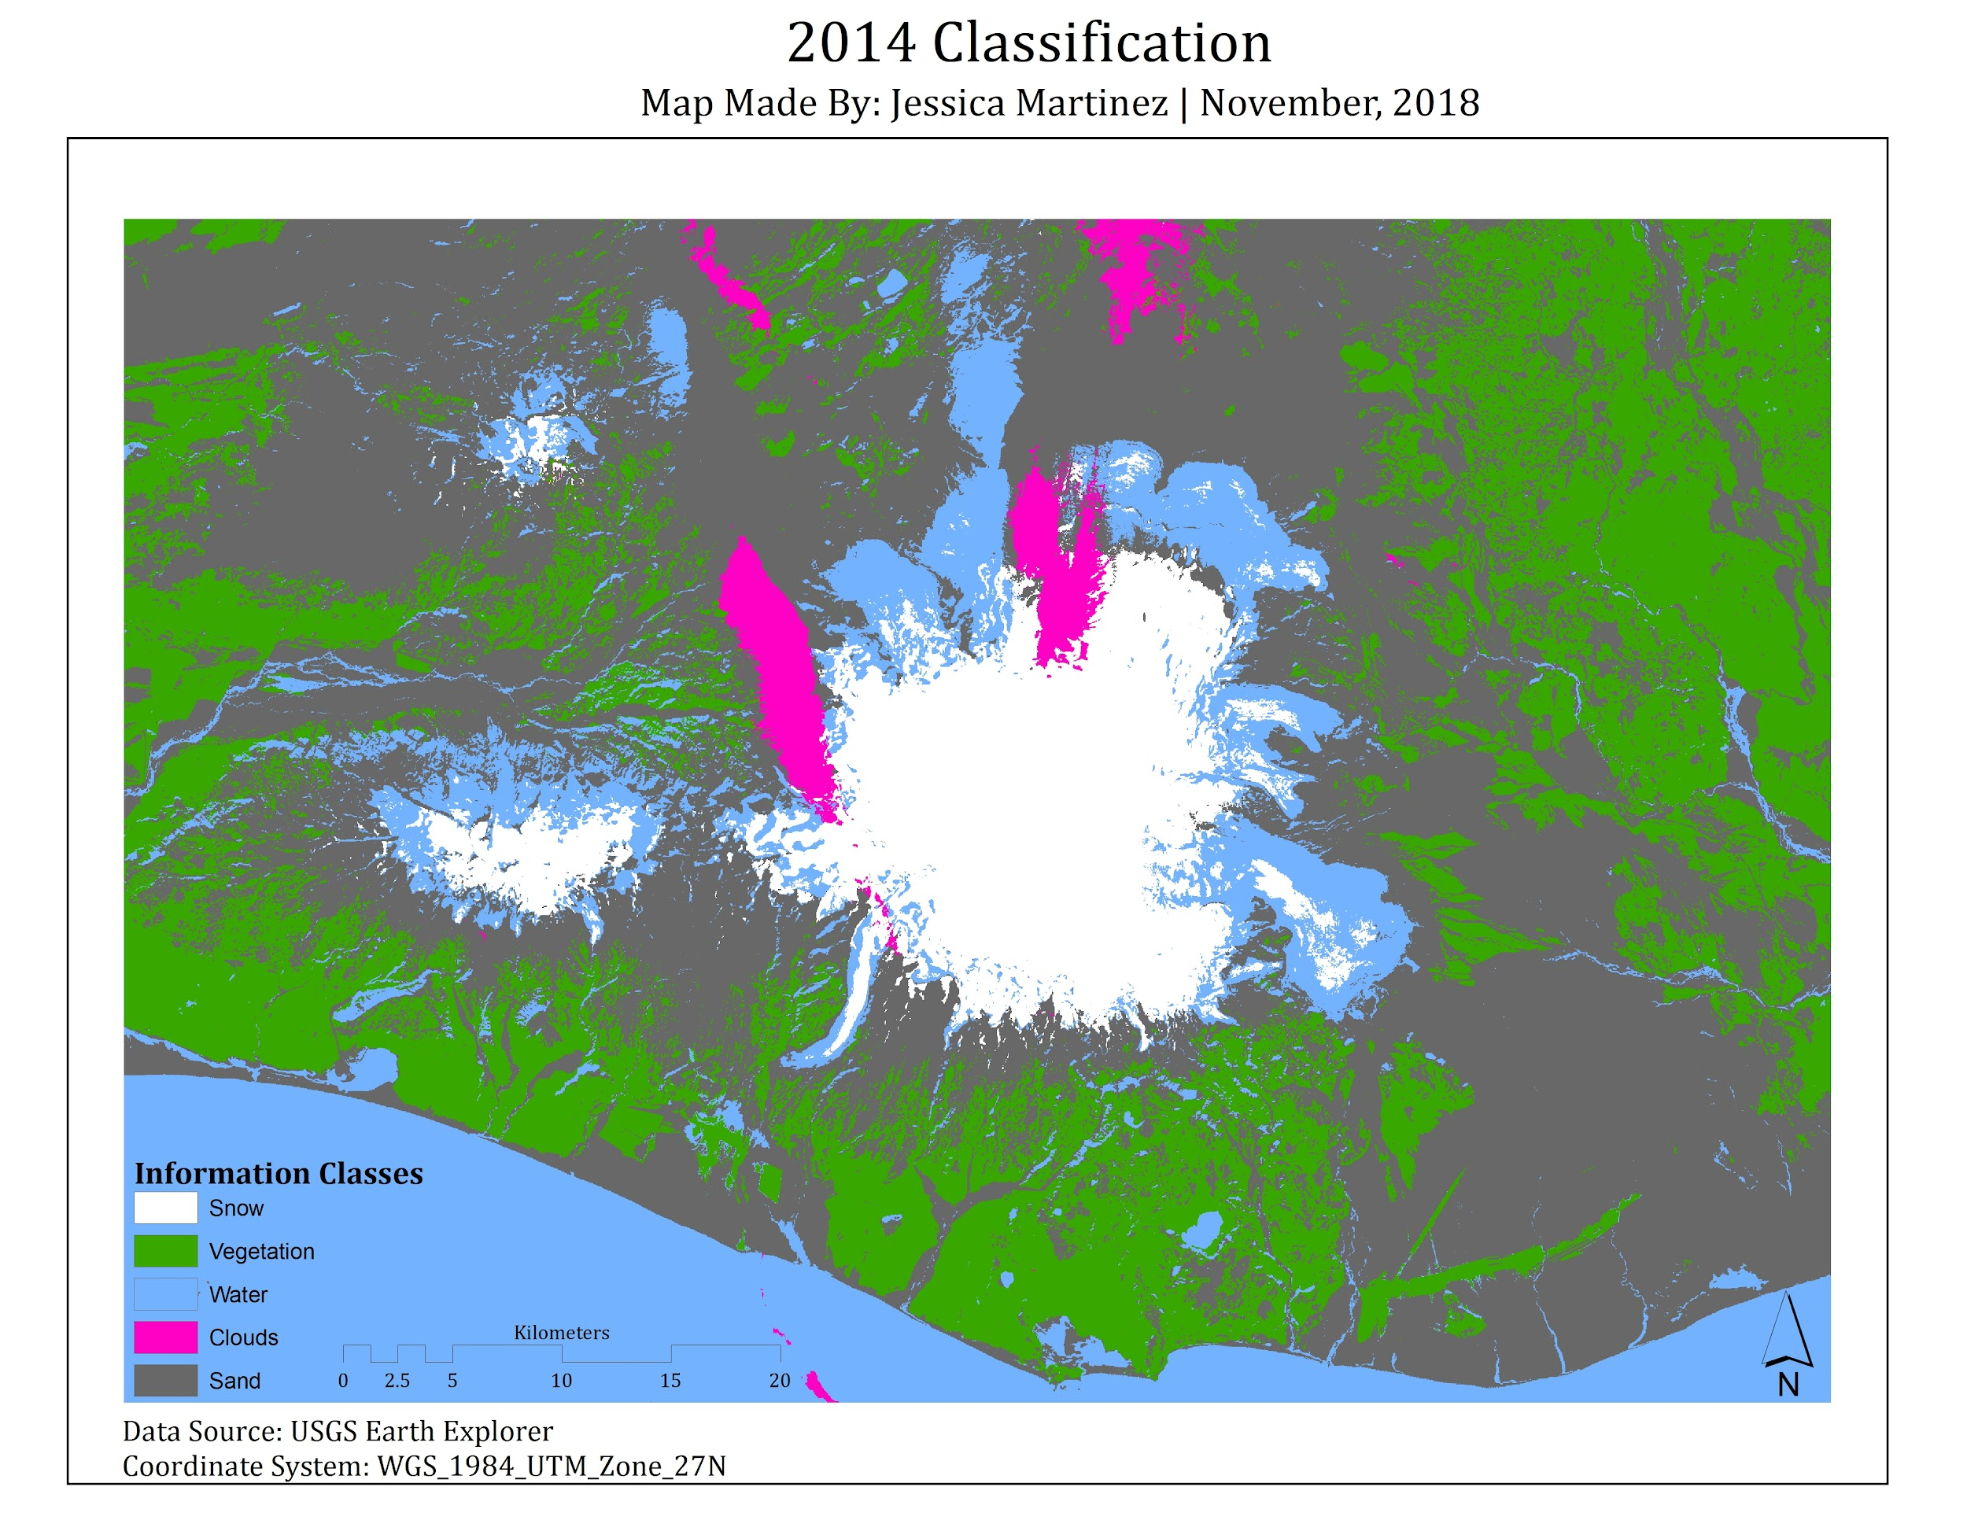

Figure 15: Results of the Linear Unmixing classification for the year of 2014

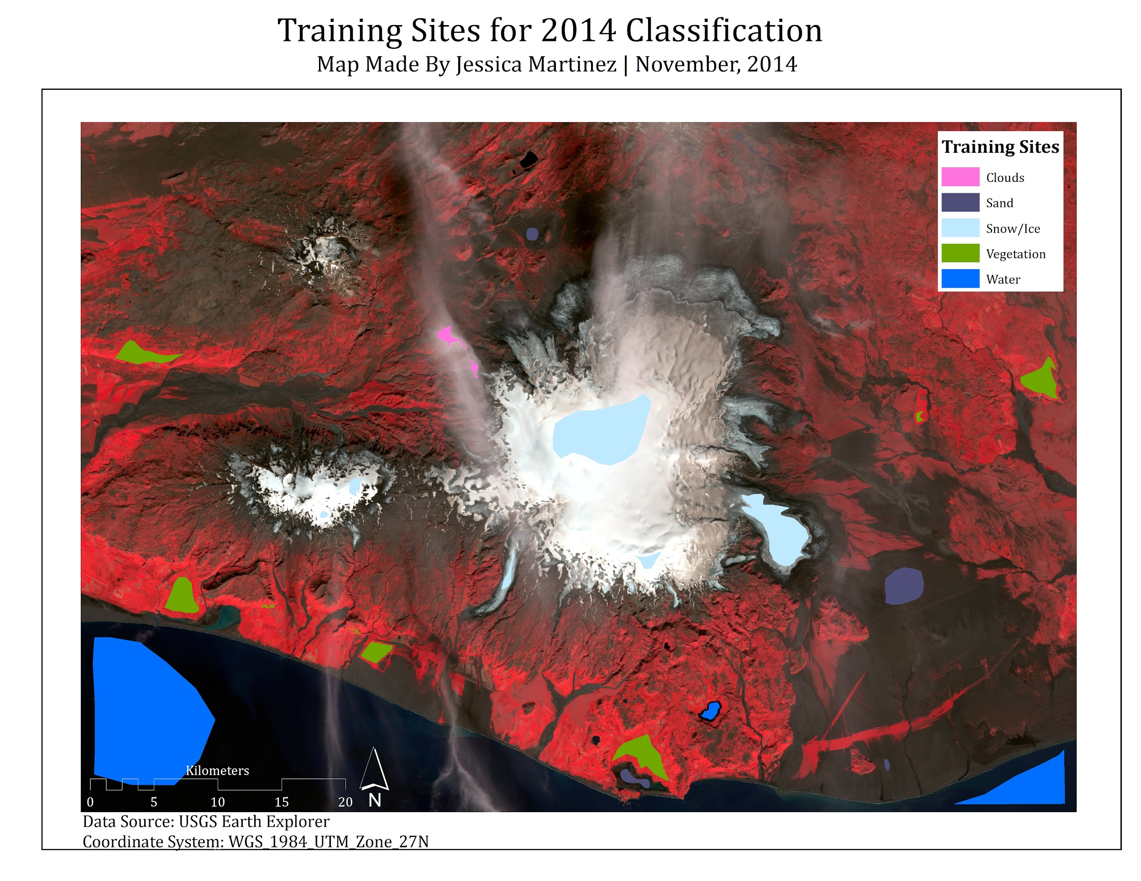

Figure 16: False color composite (green, red, NIR) including the training sites used in the 1996 classification

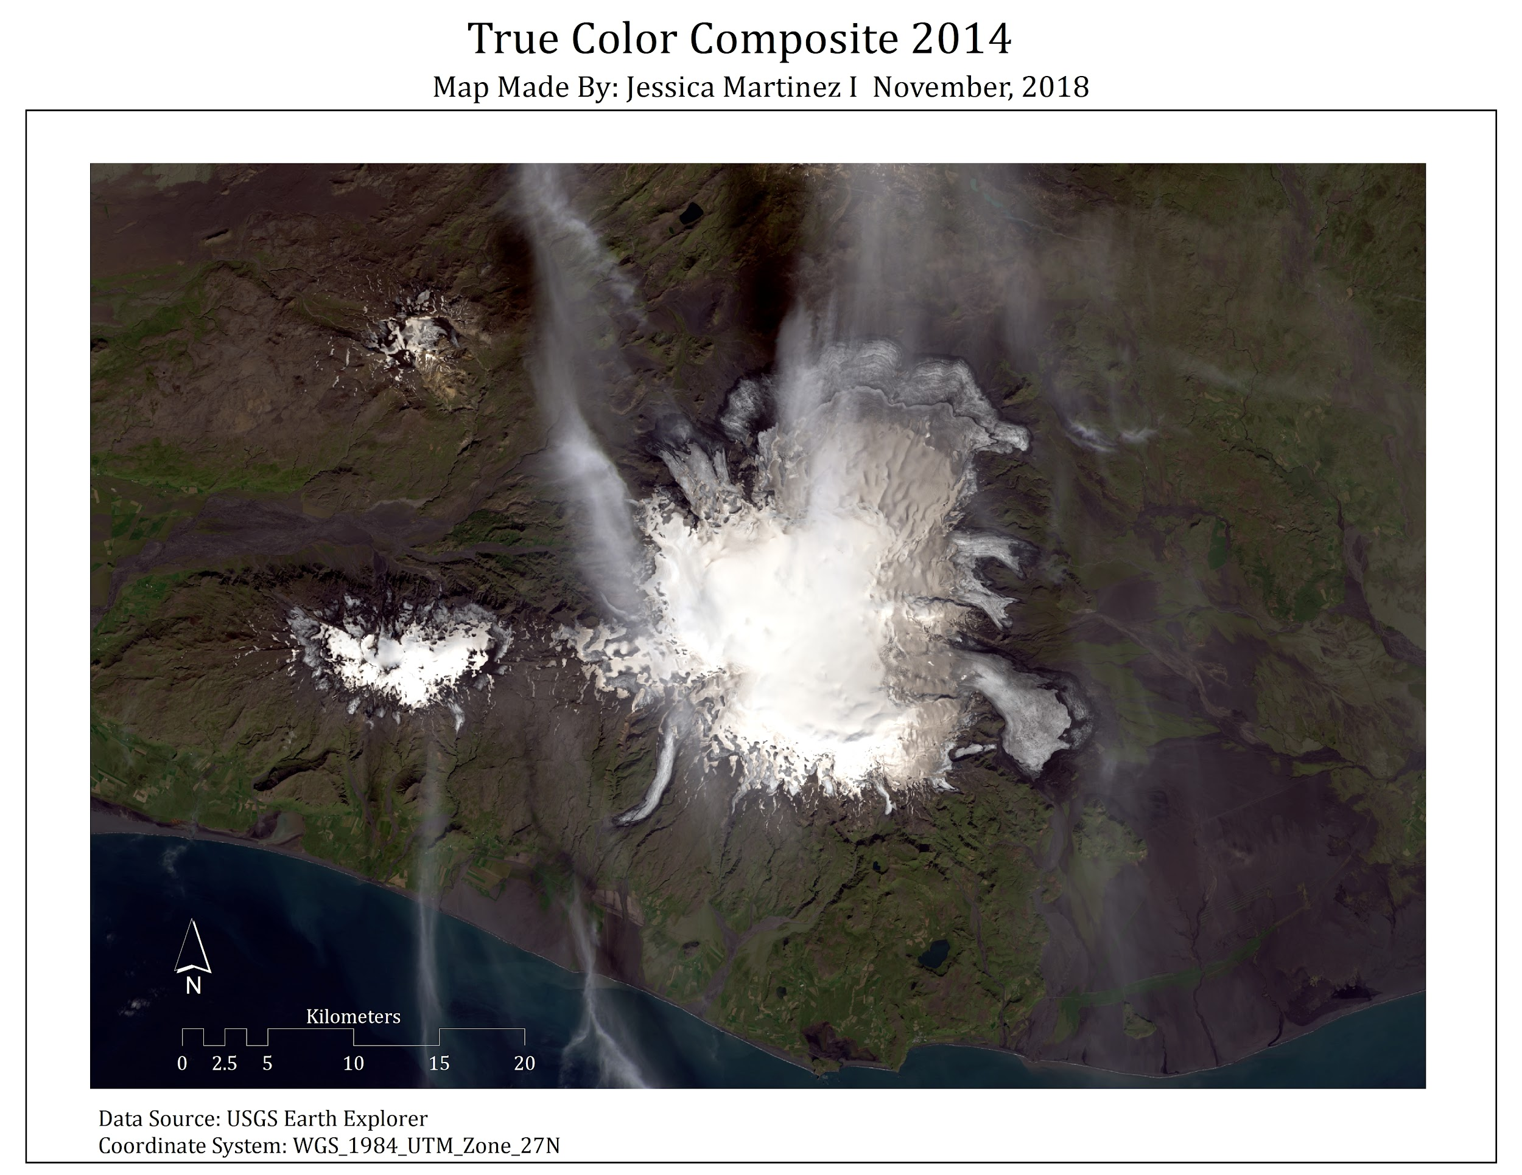

Figure 17: Windowed true color composite for the year of 2014

With the AREA module, the aerial extent for each land cover information class was calculated for each of the three images in square kilometers for clearer comparison (Figure 18). The composition of the different land cover types in 1988 is very similar to that of 1996, while the land cover extents seen in 2014 show marked differences. These drastic changes are specifically seen in the Snow/Ice information class between the years of 1988 and 2014, and in the Vegetation information class between the years of 1988 and 2014.

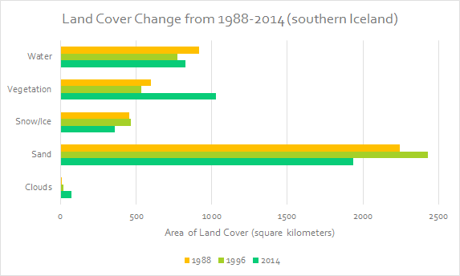

Figure 18: Comparison of land cover areal extents between 1988, 1996, and 2014

**Discussion**

The results from the 1988, 1996, and 2014 classifications show a definite decrease in glacial extent from the first date studied to the last. According to Figure 18 above, the Mýrdalsjökull and Eyjafjallajökull glaciers retreated in aerial extent by 21% from 1988 to 2014. Considering the anecdotal and scientific evidence of worldwide glacial retreat and disappearance due to global warming over the past century, this decrease confirms our predictions. In looking at Figure 18, one might notice a slight increase in snow and ice cover from 1988 to 1996. This is assumed to be an artifact of the classifications which were performed by different analysts using different training sites for each year studied. It is possible that this trend of glacial readvance actually fits into larger trends seen in the 1990’s of glaciers regaining extent lost in the previous decades, however, this study is not sophisticated enough to determine this (Evans, et al. 2017). In the future, a more fine-scale study comparing glacial extent year to year could be conducted to derive more definite results.

While overall declines of snow and ice cover can be placed in the context of global climate change, the classification images produced also contain other evidence of a warming planet. For one, there is a visual increase in water surrounding the glacier from 1996 to 2014. While Figure 18 does not give an accurate estimation of changes in meltwater because it includes surface water like lakes and the ocean found in the southern part of the image, a visual inspection of Figures 12 and 15 shows definite increases in meltwater from one time period to the next. The 1988 classification in Figure 9 shows a lot more surface water found throughout the sandy landscape than in 1996 and 2014. This may have been because the analyst who created this classification had training sites with more sedimented water included meaning that shallow ponded surface water was more readily assigned to the water informational class. Regardless, this feature of the classifications allows the examination of the dynamics of melt pond and stream formation. Remote sensing is positioned to provide analysts an aerial view of the extent of glaciers, however, their melting produces depressions and rivets of water along their surfaces which is often classified as water. So while this technique has trouble in determining absolute aerial extent of glaciers purely from classification, it benefits researchers seeking to understand the natural formation and drainage of melt ponds and streams and how global warming impacts these processes (Evans, et al. 2017).

Additionally, from 1988 to 2014 there appears to be a large increase in vegetation cover. A potential explanation for this is that as global temperatures rise many ecosystems will experience overall warming and changes in growing seasons (Leblans, et al. 2017). It is possible that Iceland will see an increase in the length of the growing season as well as more land exposed from glacial retreat to be colonized by vegetation. Less harsh winters, less snowfall, earlier starts to the growing season, and greater inputs of meltwater in this region could favor the growth and expansion of vegetation cover. It is clear that there is complexity to the ecological dynamics that govern this ecosystem.

As was mentioned in the description of data, the cirrus band (band 9 for Landsat 8), was used in the supervised classification of the 2014 image. The reasoning behind the use of this band was that the 2014 image had high, cirrus clouds stretched across a small part of the glacier while the clouds found in the 1988 and 1996 images were primarily stratus, so low in the atmosphere and fluffy, and found far from the glaciers of interest. The use of this band in the 2014 image most likely didn’t have a large impact on the classification as the final results shows no large anomalies, but is worth mentioning in the analysis. The minor presence of clouds in all images used reveals the fact that we had a lot of difficulty finding images without extensive cloud cover over the Mýrdalsjökull and Eyjafjallajökull glaciers, despite choosing times of the years when precipitation and cloud cover should have been low. Furthermore, there was striping several pixels wide in all the Landsat 7 imagery for this region from the late 1990’s to the early 2010’s, meaning our data has a large gap between the 2nd and 3rd time periods studied. We could potentially perform this study again in the future using data from other satellites to fill this gap in time.

Finally, as was discussed briefly in regards to melt pond formation, the remotely sensed data used for this study area had drawbacks due to the method of collection. As was seen in the discussion of informational classes, Iceland is known for its black sand which we treated as the default bare soil in this case. While minor error assessments revealed difficulty in separating the shrub-like vegetation from black sand in the landscape, our greatest concern lay in the fact that black sand can accumulate on snow and ice (“dirty snow”) and reduce a glacier’s albedo and change its spectral signal. This is an unavoidable consequence of using remotely sensed data and highlights the importance of ground-truthing findings, provided the resources are available to do so.

**References**

Casado, M., et al. (2018). "Archival processes of the water stable isotope signal in East Antarctic ice cores." Cryosphere 12(5): 1745-1766.

Chelsi, A. M.-J., et al. (2015). "Mapping the Impacts of Iceland’s Katla Subglacial Volcano on the Mýrdalsjökull Glacier." (3): 195.

Data collected from USGS Earth Explorer on November 8th, 2018.

Evans, D. J. A., et al. (2017). "Skaftafellsjökull, Iceland: glacial geomorphology recording glacier recession since the Little Ice Age." Journal of Maps 13(2): 358-368.  
  
Hannell, F. G. and I. Y. Ashwell (1959). "The Recession of an Icelandic Glacier." The Geographical Journal(1): 84.

Leblans, N. I. W., et al. (2017). "Phenological responses of Icelandic subarctic grasslands to short-term and long-term natural soil warming." Global Change Biology 23(11): 4932-4945.

Przyborski, Paul. “Melt Ponds on Greenland’s Ice Cap.” Earth Observatory, NASA, 2007.

Warner, T.A., Campagna, D.J., Sangermano, F. 2017. *Remote Sensing with TerrSet/IDRISI*: *A Beginner’s Guide*. Geocarto International Centre Ltd.